{{CustomerName}}
{{FullAddress}}

FAO: {{ContactName}}

{{TodaysDate}}

Our Ref: {{ProjectName}}

Dear {{ContactName}},

We would like to thank you for your recent valued enquiry.

We have now reviewed the information and take pleasure in providing the following proposal for your consideration.

Should you require any further assistance, please do not hesitate to contact us.

Yours faithfully,
{{ConsultantName}}

Consultancy Services



Consultancy Services

Scope of Works

Project name: {{ProjectName}}
Data Centre Walk Through Audit
Date: {{TodaysDate}}
Customer: {{CustomerName}}

Contents
1. Introduction 4
2. Audit Aim 4
3. Areas Assessed 4
4. Breakdown of Assessment Areas 4
5. Test Equipment 5
6. Audit Report 6
7. Audit Benefits 7
8. Price Schedule 8
9. Commercial Details 9
10. Further Information 10

1. Introduction
The Walk-around is designed to be a non-intrusive audit, specifically to support Network Room and Wiring Closet environments. These environments often face greater challenges than their larger counter parts, often surviving in a reactive scenario. To improve these environments Schneider Electric provides a non-intrusive Data Centre audit identifying areas of concern and operating improvements, incorporating checks for compliance with regulatory and industry best practices.
During the Walk-around Audit our Accredited Data Centre Consultants will identify issues and risks within the physical layout, IT Racks, power distribution, air distribution and cooling systems, security access and health & safety hazards.
Following a Data Centre Walk-around Audit, our consultancy experts will take the key recommendations provided and turn these into a constructive and practical action plan through detailed reports to support you in achieving your energy efficiency goals and ensure the highest power availability for your facility and business continuity.

2. Audit Aim
The audit is designed to provide a customer with the following end products:
- Identified observations and areas of concern
- Conclusion and Summary of audit findings with supporting evidence
- Recommendations designed to address the identified areas of concern and operational Improvements to allow a customer to formulate an Action Plan
- Evidence supported by measurements taken on-site, photographs, and Thermal images

3. Areas Assessed
As highlighted, this is a non-intrusive assessment and incorporates the following:
- Physical Layout
- Rack Management
- Power Distribution
- Airflow Distribution & Management
- Cooling
The audit will generally be completed within 1 working day.

4. Breakdown of Assessment Areas
The breakdown of the audit areas but it should be noted that this will vary from data centre to data centre subject to the physical layout, building and system architectures. Subsequently, the audit and report will be tailored to the given data centre and supporting environments:

Physical Layout | - Labelling, floorplans, and documentation  - Operational risks and areas of concern  - The condition of a raised access floor  - Floor loading capacities  - Quality of supply and return plenums  - Lighting quality  - Wasted whitespace potential  - Service penetrations into the whitespace  - Fire protection systems & firestop practices
Rack management | - Power distribution to the cabinet (including earthing)  - Effective use of power at cabinet level  - Airflow to cabinet and across the IT equipment  - Quality of cabling and patching  - Resilience and availability  - Environmental monitoring  - Identification of redundant cabling & equipment
Power Distribution | - Transformer or Utility point of demarcation  - Main Switchboard checks  - UPS checks  - Power Distribution Units (PDUs) or Distribution Panels (DPs)  - Remote Power Panels (RPPs) – if applicable  - Cabinet Power Distribution  - Power cable distribution  - Labelling and warning signage
Airflow distribution & management | - Cabinet Supply and Return Air Temperatures (SAT & RAT)  - Relative humidity (RH) and Dew Point  - Delta T across the IT equipment  - Identification of bypass & recirculation
Cooling | - CRAC Airflow rates (m³/h)  - Floor plenum pressure (positive and negative)  - Computational Fluid Dynamics (CFD)
Table 1: Breakdown of Assessment Areas

5. Test Equipment
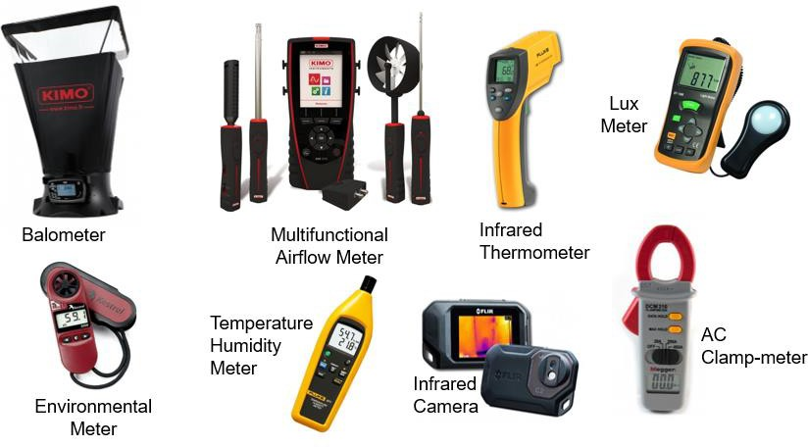
All test equipment is industry approved and fully calibrated, all calibration details will be highlighted within the audit report.
Figure 1: Audit Equipment

6. Audit Report
The report will provide detailed data analysis of problems and issues highlighted during the audit, with the identified areas of concern broken down as follows:
- Breakdown of audit data to precisely understand the areas of concern
- Evaluation of operational and business requirements
- Single point of failure and risk analysis
- Recommendations and solutions

The overall aim of the report is to provide a customer with the technical structure to establish a comprehensive action plan to resolve the identified areas of concern. The report will be delivered against the agreed audit scope and formulated from accurate collated data and not assumptions. All observations and conclusions will be supported by appropriate technical evidence utilising photo’s, test result and evaluation tables. The report will be formatted covering:
- The audit scope
- Executive summary
- Audit breakdown/overview
- Audit Assessment (areas audited)
- Observations
- Conclusions
- Recommendations
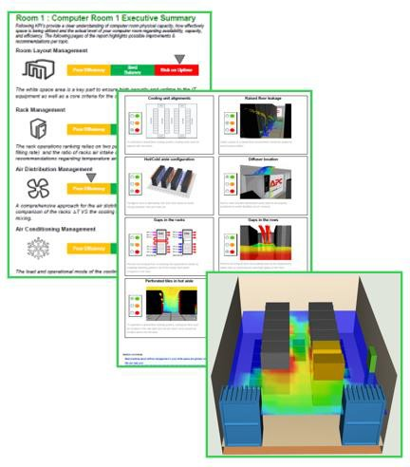
- Appendices and Tables

Figure 2: Report Extraction Examples

7. Audit Benefits
The Health-Check Audit will provide Customers with a clear baseline understanding of the operational status of their designated data centre. Key benefits including:
- Detection of opportunities for:
- Improving Cooling performance
- Optimising Airflow Management
- Increasing Power supply reliability
- Identifying Physical layout risks
- Evaluation of Rack Space management
- Improved operational Safety
- Reduced risk of operational downtime
- Identification of Asset Lifecycle
- Recommendations to Improve Data
- Centre Longevity
- Outlining a Practical Action Plan

8. Price Schedule
Item | Work Description | Price
1 | Place Holder | Placeholder
Total (ex. VAT)

The fee includes all correspondence, meetings, and document reviews pertinent to complete summary report and audit compliance.
Please note: All fees presented are for the pre-defined scope of works, any additional requirements or changes in scope can be met by mutual agreement with the opportunity to revise costs and timescales proportionally.

9. Commercial Details
Validity | Our offer is open for acceptance for 60 days from the date of this quotation ref {{ProjectName}}
Delivery | Based on our present knowledge of availability of personnel and our current programme, we estimate work commencement to be typically 4 working weeks after placement of order and receipt of all information requested in this quotation.  However, should this period be outside your requirements, we would be happy to discuss your needs in more detail.
Order | We would require an official purchase order related to and referencing this proposal. Please send orders to the address and Bid Engineer detailed on the front page of this quotation. A copy of the order should also be emailed to the Bid Engineer.  To be processed without delay your order should include the following information:  - A valid Purchase Order  - Our reference – {{ProjectName}}  - Agreed price  - Formal acceptance of Schneider Electric’s general conditions of sale
Payment Terms | The price(s) quoted are based on the following Payment Terms  - {{PaymentTerms}}  Important Notes:  It is assumed that the project would be completed within 8 weeks of receiving a valid purchase order. Should the project not be completed within this period, we reserve the right to invoice the work completed to that date and review the price of the remaining work according to the newly agreed timescale  Payment Terms offered are subject to satisfactory findings of our routine credit status check.  We understand that the above payments are not subject to any retention.
Conditions | Our offer is made in accordance with Schneider Electric Terms & Conditions UK & Ireland, a copy of which is available upon request or can be found at:  http://www.schneider-electric.co.uk/documents/general/legal-information/Schneider-Electric-Conditions-of-Sale.pdf#page=1  However, we confirm we are prepared to discuss mutually acceptable terms and conditions prior to any contract award should the Schneider terms prove unacceptable.

10. Further Information
Basis of Offer | - Our offer is based on the following requirements.  - Our working requirements.  - Normal working hours would be between 08:00 and 17:00 weekdays and excludes Bank Holidays. Any hours to be worked outside of these times would be charged extra.  - On shore working.  - Unrestricted access to site as and when required (accompanied)  - Work can continue uninterrupted without delays by other parties.  - Unless otherwise stated all work is office based. Site visits and attendance at meetings would be a chargeable addition based on our standard rates.  - Unless a survey has been carried out by Schneider Electric all work is based on information provided to us. We accept no liability for the accuracy or validity of this information how so ever provided.  - Any required changes to the work as a result of inaccurate or invalid information would be a chargeable addition based on our standard rates.
Not Included in Our Offer | We have not included for any of the following:  - Installation of any equipment.  - Commissioning of any equipment  - Attendance at any meetings unless otherwise stated in the scope of works
Standards | Schneider Electric Ltd complies with and works within the following standards:  - ISO14001  - ISO9001  - The Management of Health and Safety at Work Regulations.  - Health and Safety at Work Act.  - BS7671:2008 Requirements for Electrical Installation  - The Provision and Use of Work Equipment Regulations.

